**Assignment1**

**September 13rd Tengfei Jiang**

Problem1:Thresholding

1.Threshold1:

2.Threshold2:

Problem 2 Contrast/Inversion

1.Increase the brightness by 10% by subtracting the value of 25:

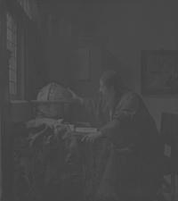

Decrease the brightness by 10% by subtracting the value of 25:

2.invert the color

The result made by imcomplement() is the same as the result made by pixel processing

Problem 3: Quantization

1. 8 levels:

1. 16 levels

Problem 4: Sampling

1. By the factor of 2:

1. By the factor of 7

Playing with a Camera:

I took 20 pictures with my EOS R6 camera and size of files are too big to be submitted within the zip file.

If the original images is required, please let me know.

1. Mean Image:

1. Deviation image:

1. Maximum Difference from the mean image, How big is this? Does it depend on the mean?

MD(R,G,B)=50,46,48;

It is not dependent on the mean image.

1. Distribution of pixel intensity, why does it look like that?

The distribution of pixel intensity looks like Normal Distribution. Under the same (at least very similar) illumination condition, the color intensity which collected by CMOS can be seen as a real-valued random variable.